**Product of the Month**



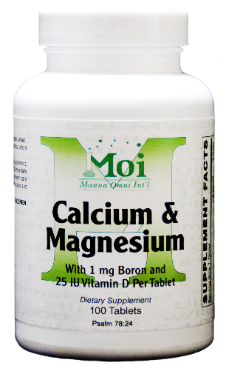

**Provides calcium to promote bone growth, bone density, and bone strength. Helps build and maintain strong healthy bone structure.**